Exercises: Web, Forms and Routing
Problems for exercises and homework for the "Web Dev Basics" course from the official "Applied Programmer" curriculum. In these exercises we will create a very simple HTTP Server. We will extend it every time and design it to mimic Microsoft’s IIS.

Implement Routing
The goal of this task is to implement routing, which means that we will be able to map request URLs to certain responses like this:
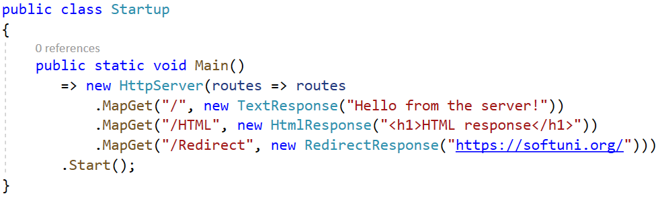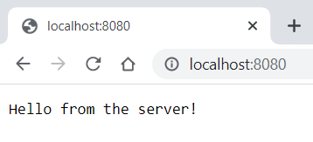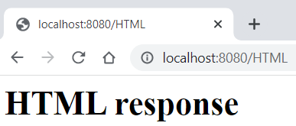

Step 1: Add Specific HTTP Responses
Our first task in this exercise is to create different types of responses, which will be later returned by our server.
Start by creating a folder called "Responses" in our "BasicWebServer.Server" project and there we will put our response classes:
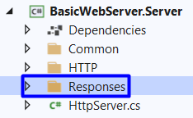
We will create two types of responses here: action responses and content responses. Our action responses will include responses for different status codes, except for the "200 OK", as when the request is successful a content response is returned. We will define action classes for "302 Found", "400 Bad Request", "401 Unauthorized" and "404 Not Found" responses and content responses for returning a plain text or HTML.
Classes should have the relations, shown in the diagram below:
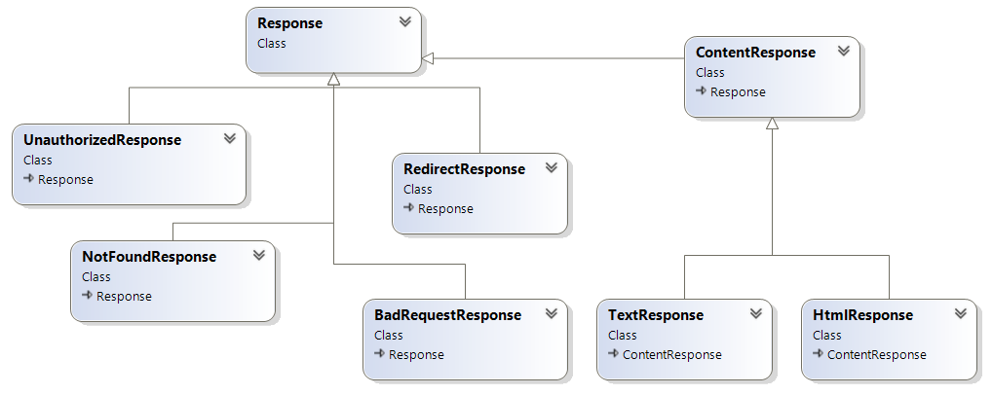
Start by adding status codes to the StatusCode enum class for the action responses like this:
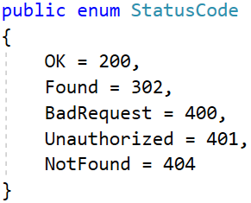
As you know, different HTTP responses are defined by their headers. Each header should be added to the response, which means that we should be able to iterate through the headers collection. For this reason, our HeaderCollection class should implement the IEnumerable interface and have the two GetEnumerator() methods. Modify the HeaderCollection class like this:
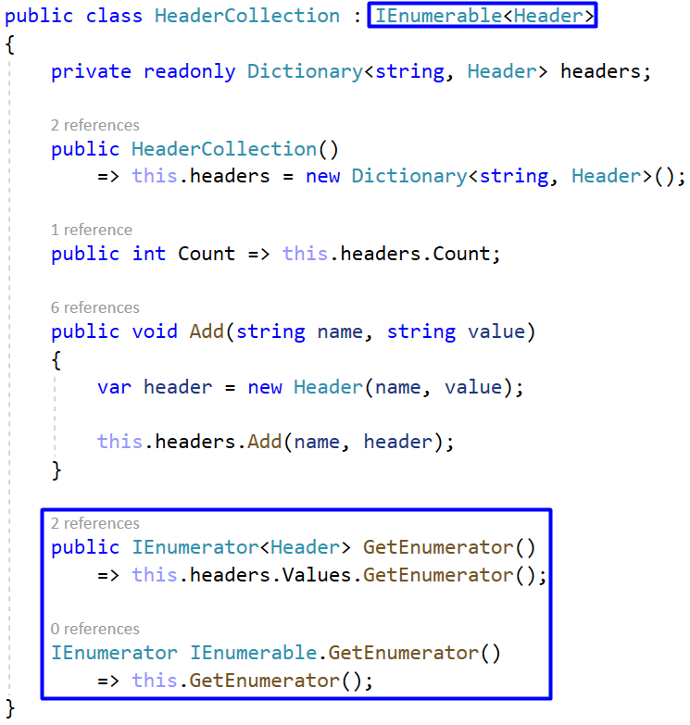

Now let’s create a base class for all action responses. They should all inherit the Response class. Let’s create the "Bad Request", "Not Found" and "Unauthorized" response classes, as they are all with the same structure. Each of them should only use the StatusCode class and set the corresponding status code of the response.
Write the BadRequestResponse, the NotFoundResponse and the UnauthorizedResponse classes like this:
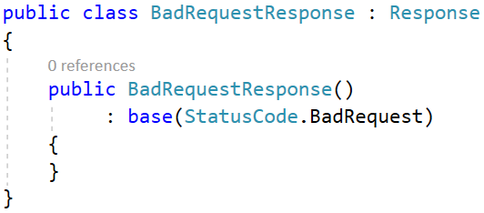
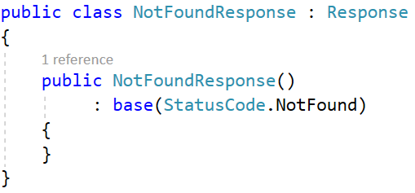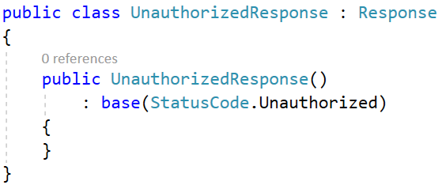
Our last response is the "Redirect" response. It also sets a status code but also an additional header for the location (the URL of the page, which the server should redirect to).
Before we write the RedirectResponse class, let’s add all header names to the Header class as constants, so that they are not hardcoded anymore. Add the following lines to the Header class:
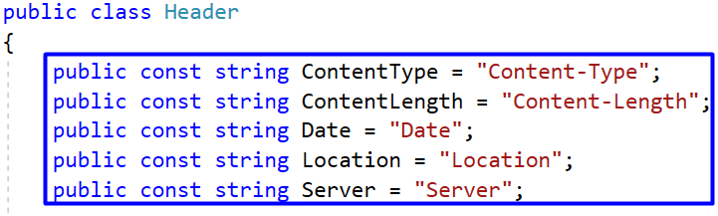
We can also now improve the Response class by using the constants from above:
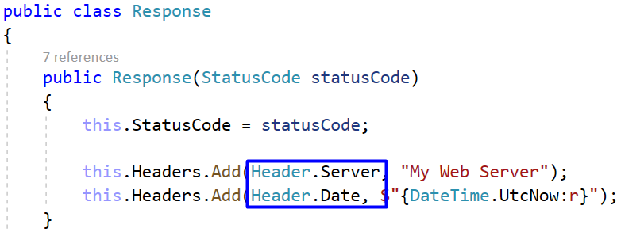
Now let’s go back and write the RedirectResponse class, which should set the status code and add a location header:
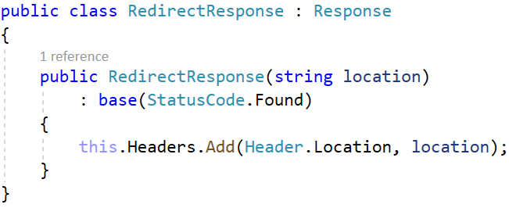
We already have classes for our action responses.
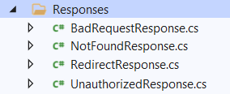
Let’s create content responses now – one to return the response as HTML and one to return it as a plain text. It is a good idea to create a class with constants for those content types. Create the ContentType class in the "HTTP" folder and add the constants like this:
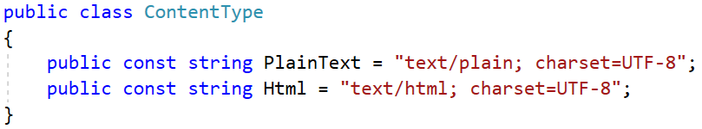
We want to create a base class called "ContentResponse", which should be a base class for all content responses and should inherit the Response class. The ContentResponse class should also accept content and content type. The content type should be added as header values to the HTTP response and its body should have the content. If you remember, we also need to add the "Content-Length" header to the response but we will see how to do this later.
Write the class as shown below:
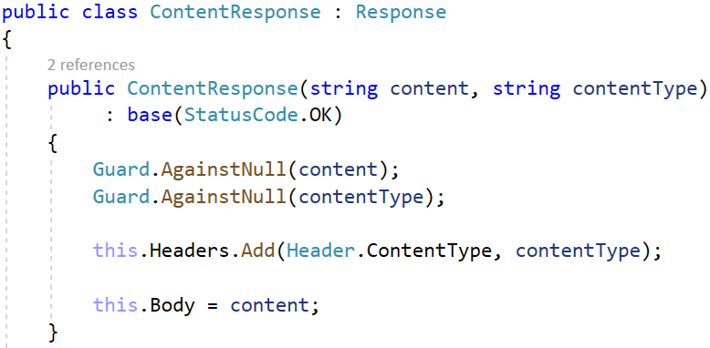
Create the HTML and plain text response classes. They should both accept the content and set a content type from the ContentType constants class. Write them as shown below:
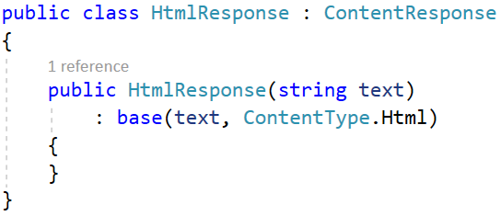
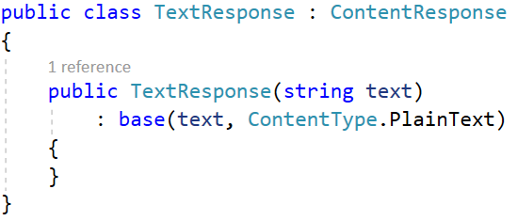
We will see how to use these classes to return specific HTTP responses to the browser later in the exercise.

Step 2: Implement Routing Table
Our task now is to implement a routing table to map an URL to an HTTP response. First, create a folder called "Routing" in the "BasicWebServer.Server" project, in which we will create our routing classes.
Next, we will create the IRoutingTable interface, which will have a method, accepting an URL, an HTTP method and a response, and another two methods for "GET" and "POST" requests, accepting only an URL and a method. The interface looks like this:
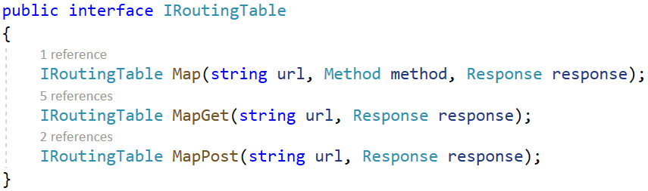
Create the RoutingTable class, which should implement the IRoutingTable interface. It should also have a nested dictionary field, in which the HTTP method is assigned an URL and an HTTP response – these are the routes. Write the class and its field:
Next, create a constructor, which initializes the main dictionary. Then, depending on the method, it should also initialize the nested dictionary:
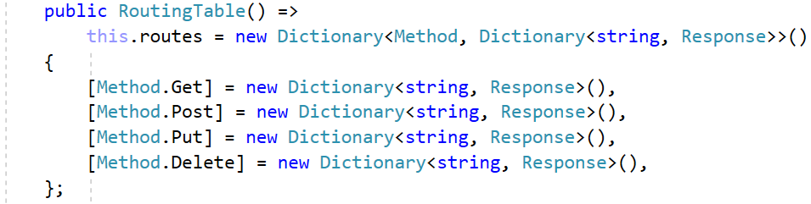
As you can see, the code structure is very unpleasant. It can be improved with the new operator, which you can use to initialize a variable of a known type. Modify the constructor:
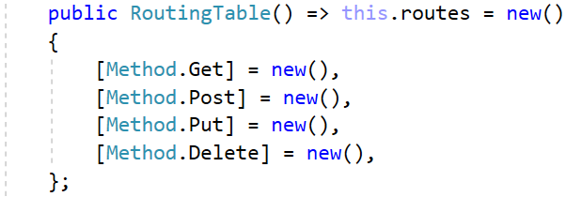
Let’s implement the Map(string url, Method method, Response response) method, which invokes another method, depending on the HTTP method, or throws an error. For now, we will support only the "GET" and "POST" HTTP method. Write the mapping method:
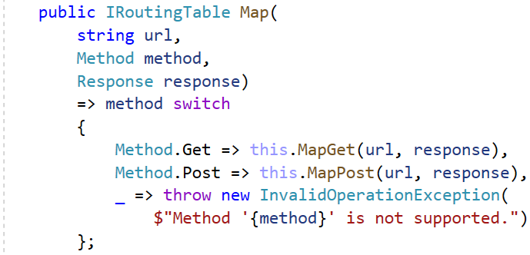
The MapGet(string url, Response response) method should map the given URL to the HTTP response (fill in the nested dictionary). The method should return the current IRoutingTable instance when done, so that we can chain mappings:
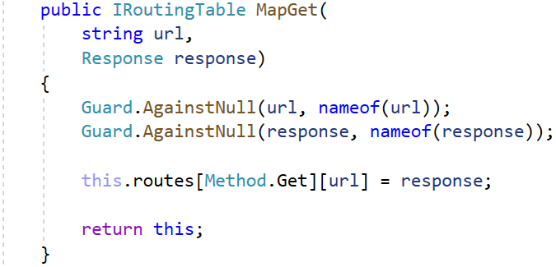
The mapping method for the "POST" request is almost the same but it differs in the method – it should be "POST":
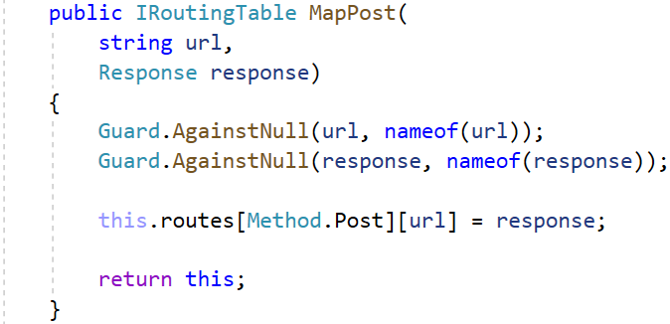
Finally, we should also add a method to get the HTTP response of an existing HTTP request, as we are going to need it. In this method, get the HTTP method and the URL of the request and return the response as shown below. If the request is not present in the dictionary, return a "Not Found" response:
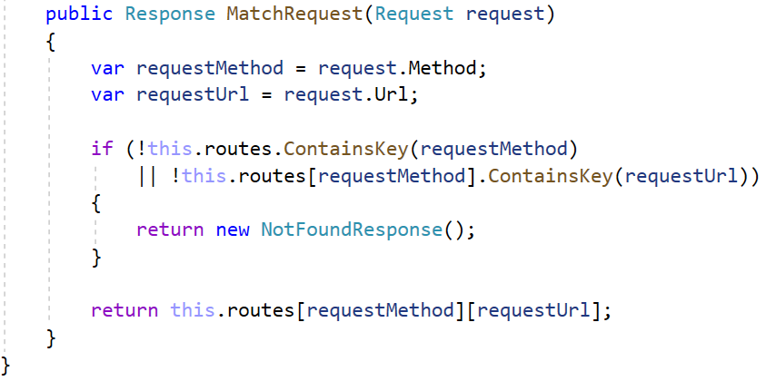
Our routing table now supports "GET" requests. Let’s see how to use it to map requests to responses and see the response in the browser.

Step 3: Use the Response Classes and Routing
Our first task is to integrate the routing table in our server. Go to the HttpServer class and add a field for the routing table. The constructor will accept a function Action<IRoutingTable>, not just IRoutingTable, as we want to enhance the way we will define routes later. Add routing to the server like this:
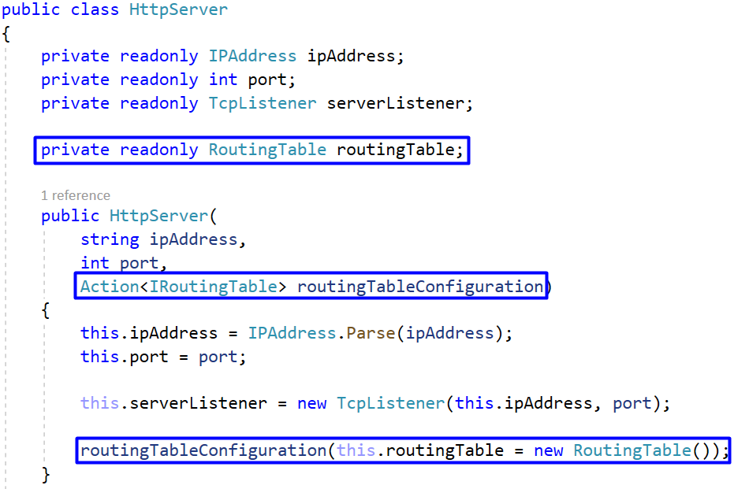
Let's create two more constructor methods, which use our current one. The reason to do this is to have a default IP address and port, so that they should not be given every time. Create the additional constructors:
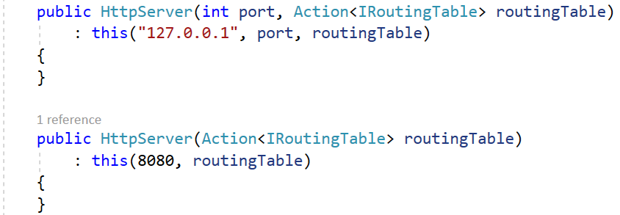
Until now, the Start() method of the HttpServer class simply printed the HTTP request from the browser on the console. Now we want to read the request, parse it to an HTTP request, get the response of that request from the routing table and write the response to the network stream. Modify the Start() method. We already have the request text – use the Parse(string request) method of the Request class to parse the request to an HTTP request:
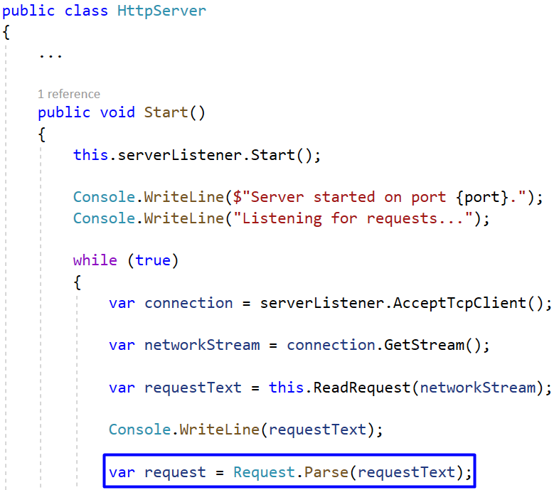
Then, use the MatchRequest(Request request) method of the RoutingTable class to get the response:
Finally, write the whole response to the network stream. The WriteResponse(NetworkStream networkStream, string message) should be modified to accept the response, which we will do on the next step. Now pass the response to the method and close the Start() method:
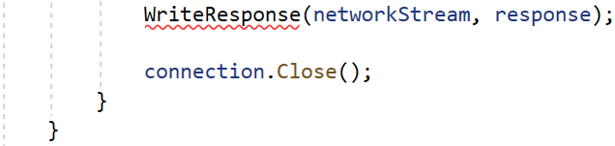
Let's modify the WriteResponse(NetworkStream networkStream) method, as well. If you remember we hardcoded a response like this:
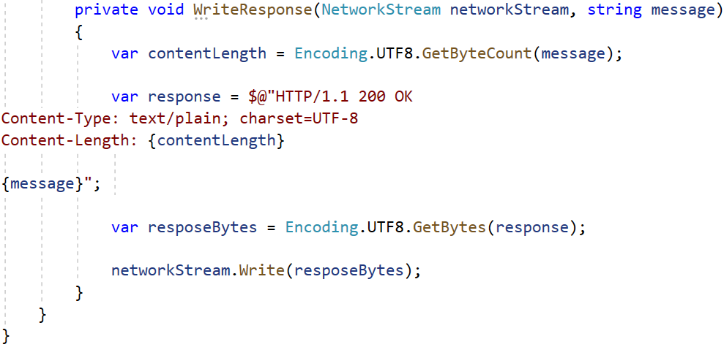
As we have the response, improve the method to accept it and write it to the network stream. Note that the HTTP response should be converted to a byte array. To make that possible, it should first be converted to a string in a valid HTTP response message format. That's why we will override the ToString() method of the HTTP response in the Response class:
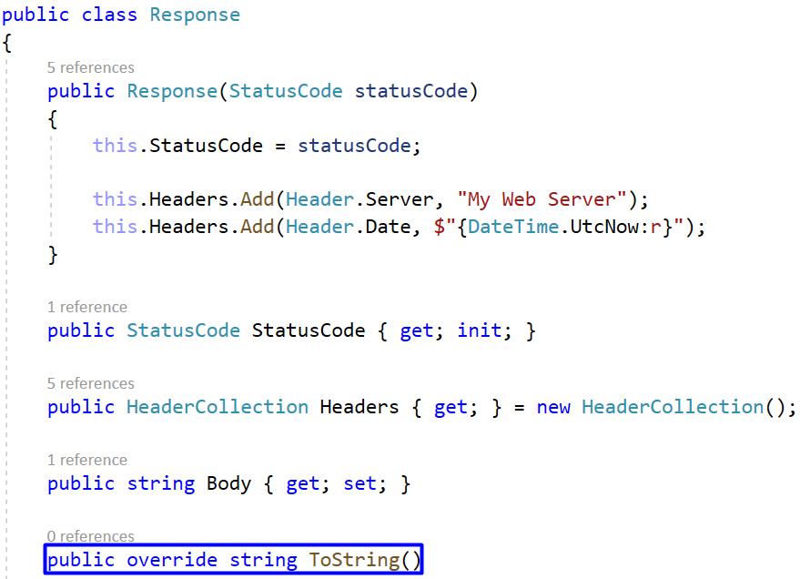

In the ToString() method we should initialize a StringBuilder variable to keep our request message lines. Add the response status line, each of the headers and the body on separate lines. Note that the body may be empty and should not be appended. Return the StringBuilder as a string. The whole method is the following:
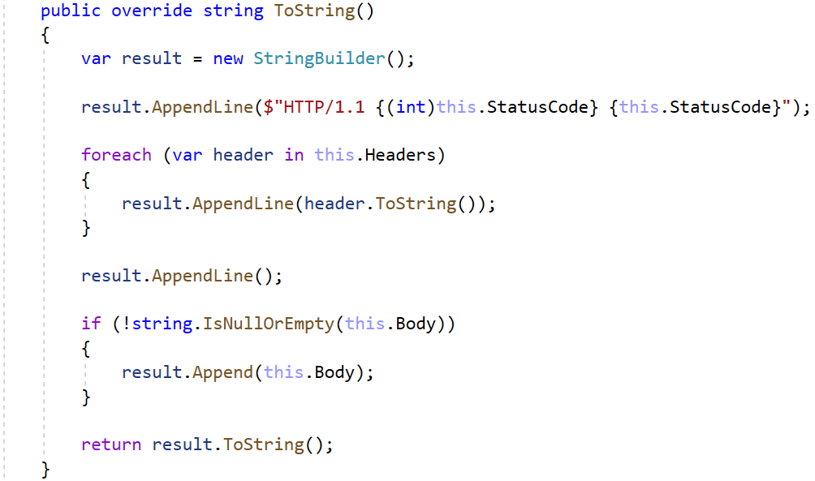
Note that we use the ToString() method of the Header class to convert the headers to string. However, we need to override that method, too, so that our headers are in the format we want. Go to the Header class and override the ToString() method like this:
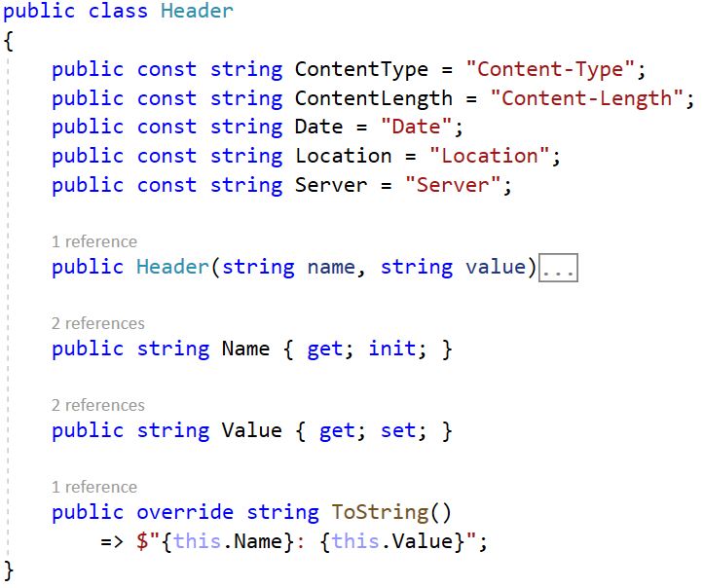

Also, we need to modify the ContentResponse class. It uses the ToString() method of its base Response class but it should add the "Content-Length" header when the body has content. We should not add the header in the class constructor, as the body may change after the initialization of the response class, and the content length value won't be correct – this will result in a wrong display of the content.
Go to the Content class and override the ToString() method. If the body is not empty, add the "Content-Length" header, which should get the body content length in bytes. Finally, invoke the base method:
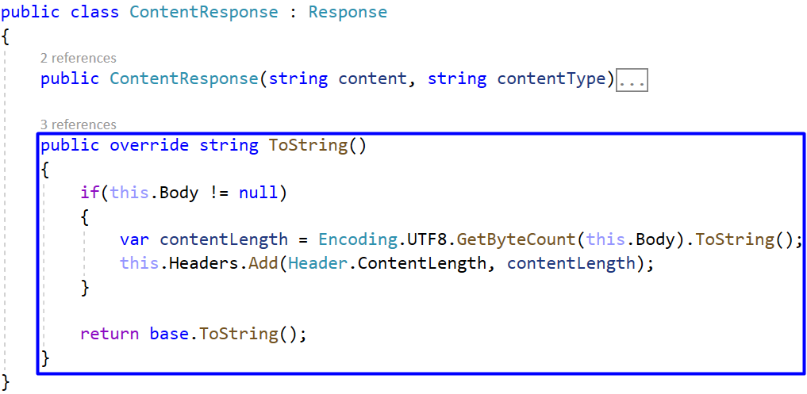
Now go back to the HttpServer class and modify its WriteResponse(NetworkStream networkStream, string message) method to accept a response, turn it to a byte array and write it to the network stream:
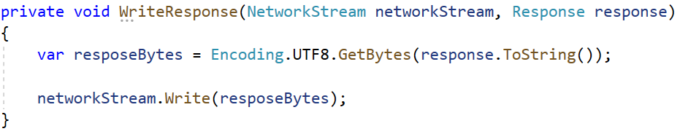
Now our server can read HTTP request from the browser and return a response because of the routing we added. To use the routing, we should create a routing table and map an URL to a response.
Do this in the Startup class of the "BasicWebServer.Demo" project. Use the MapGet(string url, Response response) method of the RoutingTable class. Try mapping URLs to different responses. We will try to return a text, an HTML and a redirect response:
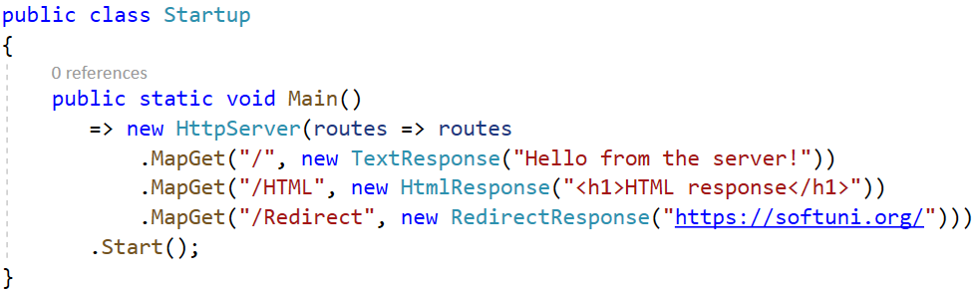
Note that we are able to chain the mapping commands because we used the Action<IRoutingTable> function in the HttpServer class. Try the routing in the browser. Run the "BasicWebServer.Demo" project and go to the localhost address with the correct port. The correct text response should be displayed on the browser:
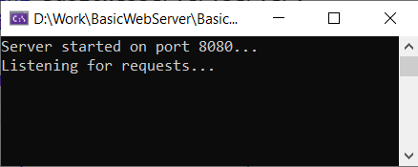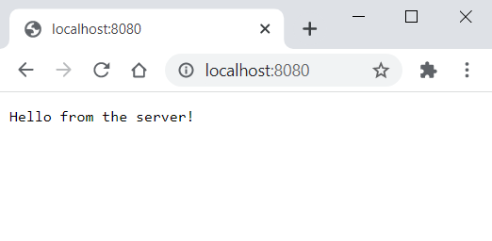
Examine the request method and status code and the returned response headers in the browser DevTools:
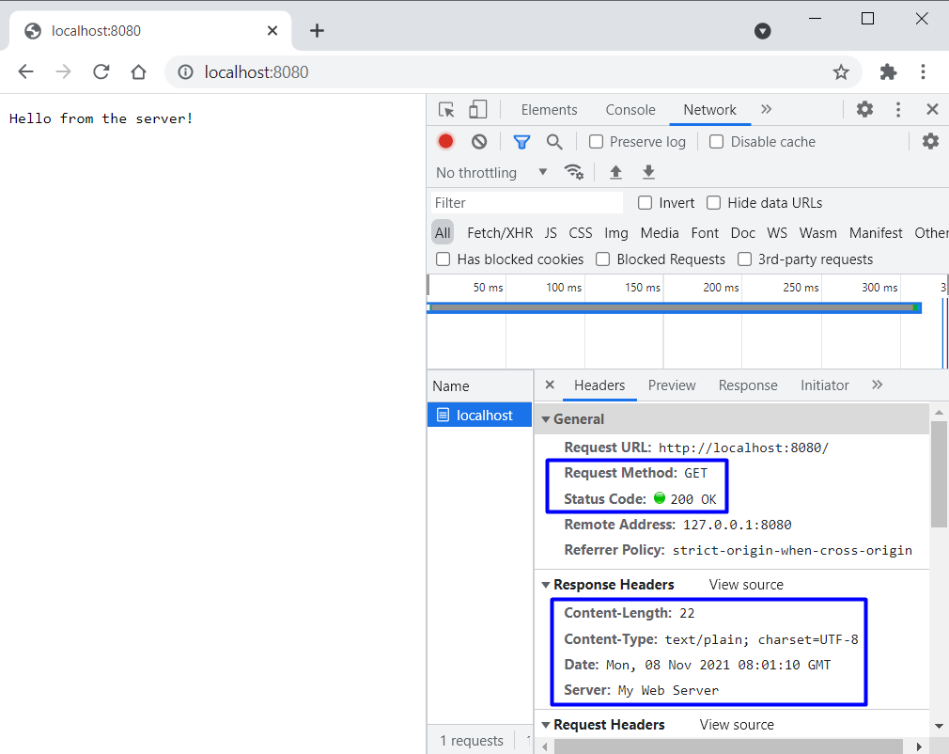
Try accessing the "/HTML" route – it should return the response text in an HTML format:
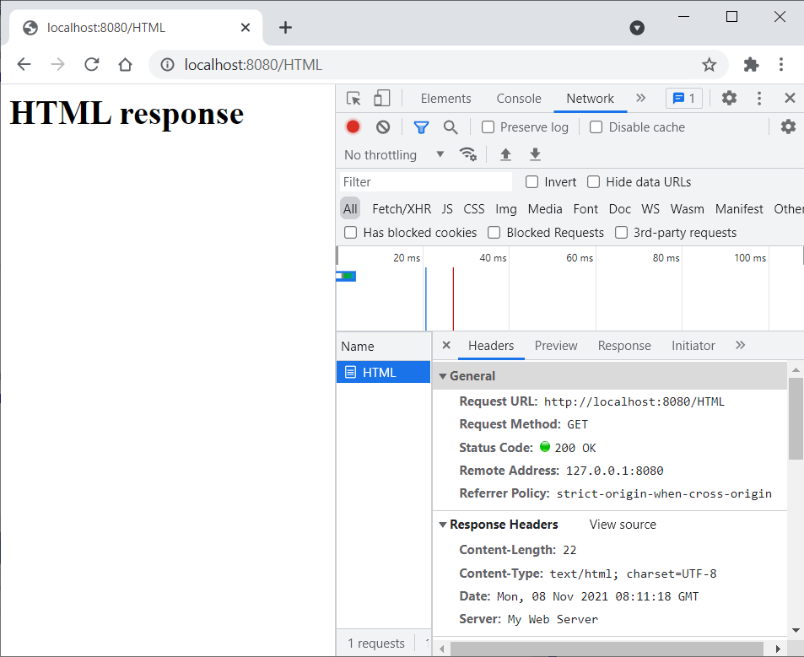
Try the redirect response on "/Redirect", as well. You should be redirected to the https://softuni.org/ site. Examine the request method and status code. Also, note that the response headers contain the one for the location, which we added especially for the redirect response:
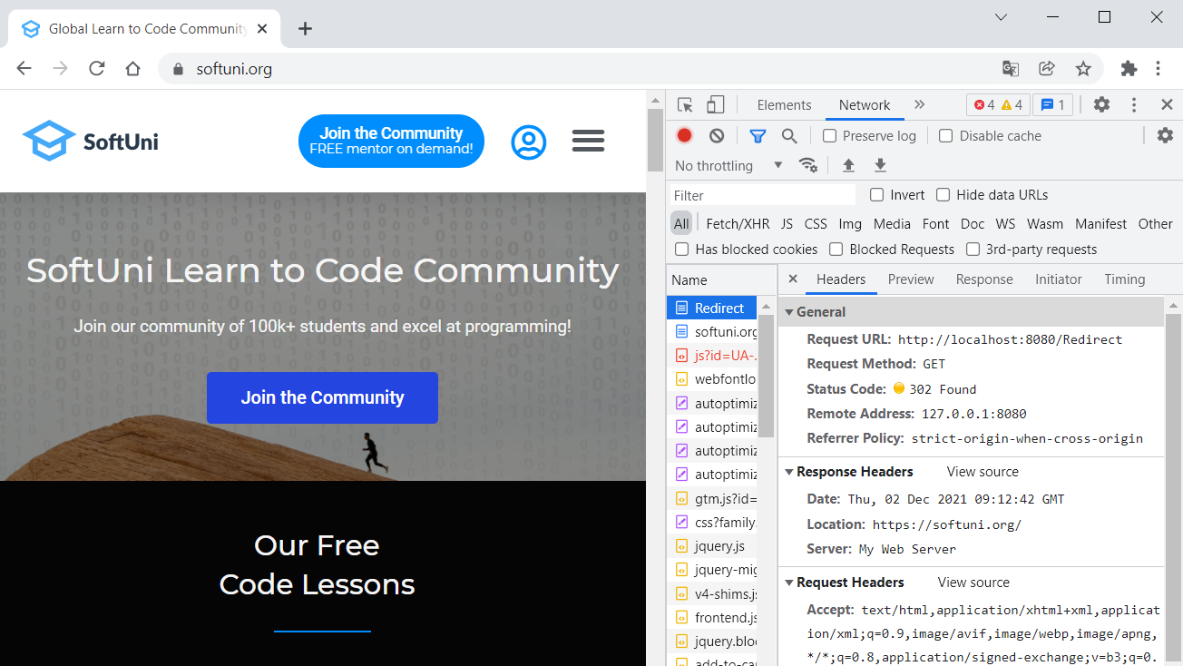
Now we have routing in our HTTP server and can return different types of responses.

Add Form Functionality
In this task we will create a simple HTML form and see how to obtain and use the submitted form data. We want to have a form for submitting name and age. When we enter data and click on the [Submit] button, a "POST" request should be sent to the server. Then our server will display the form data, which was submitted, as a text.
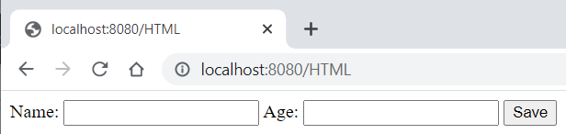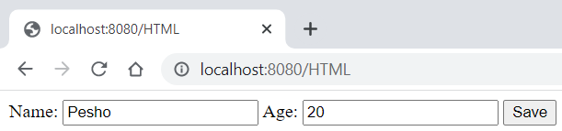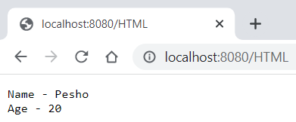

Step 1: Create the Form and Map Requests
As you can see, we should visit the "/HTML" route and a form should appear. Create the form as a string constant and use it as a part of an HTML response in the Startup class of the "BasicWebServer.Demo" project. The form should have action and method attributes as shown below:
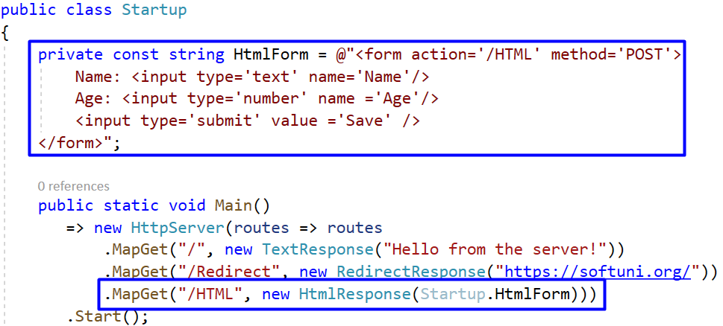
You can copy the form field from here:
private const string HtmlForm = @"<form action='/HTML' method='POST'>
Name: <input type='text' name='Name'/>
Age: <input type='number' name ='Age'/>
<input type='submit' value ='Save' />
</form>";
Now we should set the action of our form to "/HTML" and the method to "POST". This means that when the form is submitted, it will send a "POST" request to the "/HTML" path:
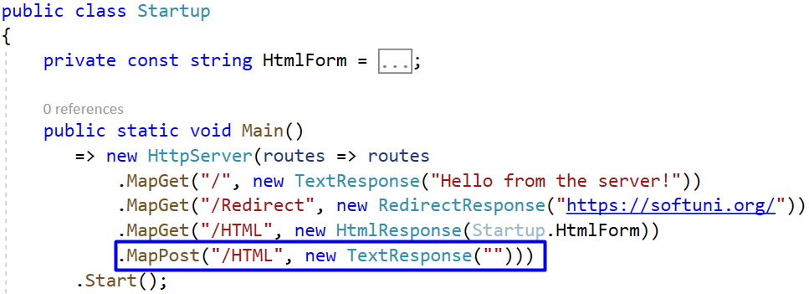
If you open the browser now and visit "http://localhost:8080/HTML", you should see the form we created. However, if you press the [Submit] button, you will not see the form data on the page, as we returned an empty TextResponse:
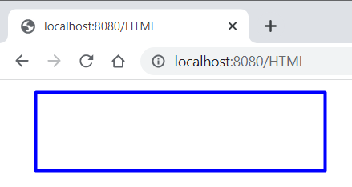
However, the form data we sent is part of our request body and you can see it in the "Payload" tab:
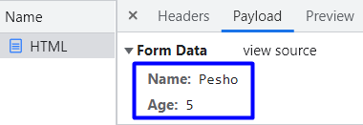
Our task now is to read that data separately from the body and use it.

Step 2: Implement Form Parsing in the Request
Let's see how to make our server read form data. Before that, do some additions to classes, which we will need later. Go to the ContentType class of the "BasicWebServer.Server" project and add a constant for the form content type, as we will need it to parse the form:
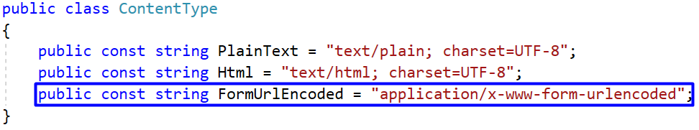
Also, in the HeaderCollection class we will need a Contains(string name) and an indexer. Indexers allow instances of a class to be indexed just like arrays and the indexed value can be set or retrieved without explicitly specifying a type or instance member. Our Contains(string name) method will return whether there is a header with the given name.
Add the indexer and the method to the HeaderCollection class like this:
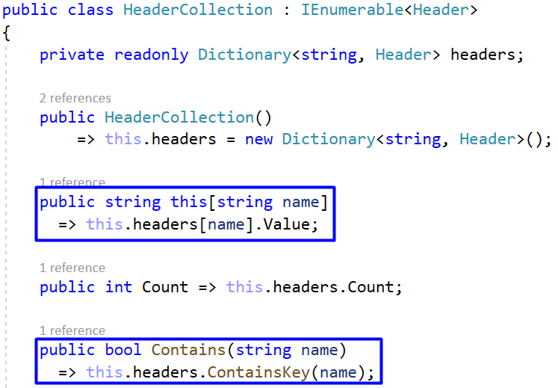

Now we can see how to parse and use our form data. In addition, it is a good idea to modify the Add(string name, string value) to use the indexer – this way if the header already exists it won't be added to the collection, which prevents you from duplicating headers. Change the method like this:
The form data is part of our requests, so modify the Request class. Start by adding a field for the form data, which should be a dictionary holding key-value pairs for the name and value of each form field:
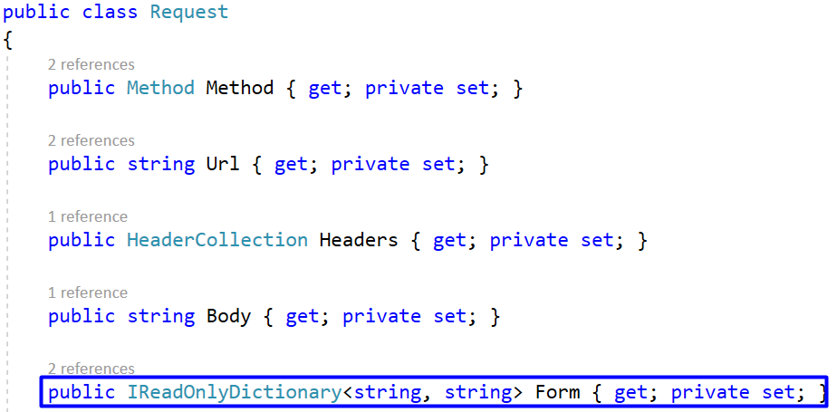

Then, the parsing of the form should be part of our Parse(string request) method. The form parsing will be in a separate method, which we will implement later. Now get the form and make it a part of the request in the method like this:
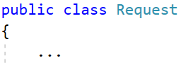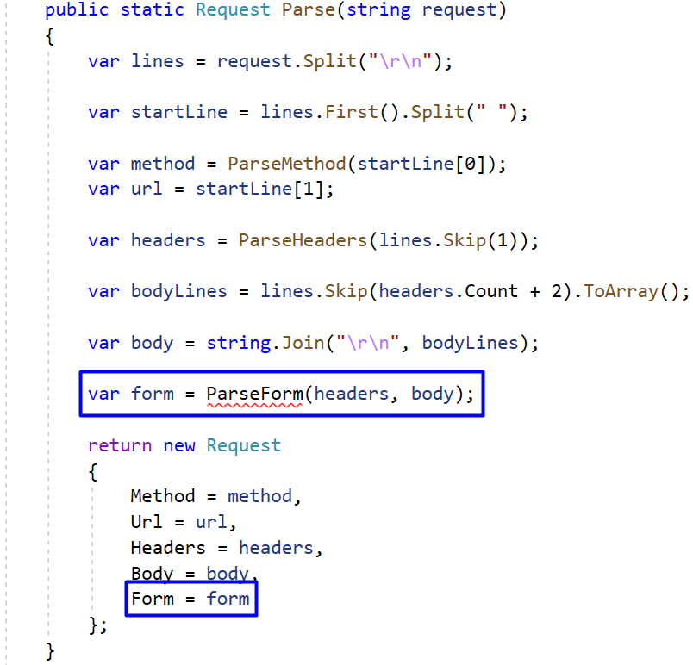
Now implement the ParseForm(HeaderCollection headers, string body) method. It should return a collection of form data pairs. Create the method and initialize the collection like this:
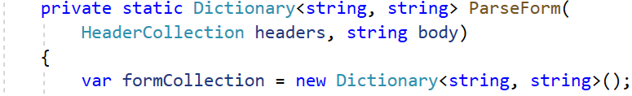
Check whether the headers contain the "Content-Type" header for forms:
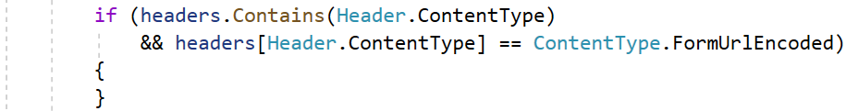
If the if-check returns true then we have a form and we need to parse it. For parsing we will create a separate method in the Request class – ParseFormData(string bodyLines). The method will accept the request body as a string, decode it and split it into parts to get the key and value of each pair of form data. It looks like this:
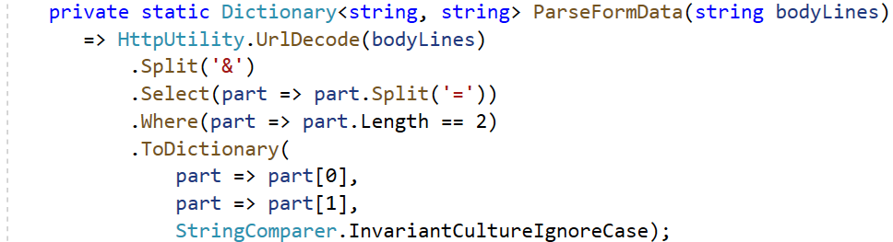
 | You need to decode the URL-encoded form data, using HttpUtility.UrlDecode(string). Otherwise, special characters like "/" or " " in the form fields will remain encoded as "%2F" or "+".
Use this method in the if-statement from above and parse the form to a dictionary. Then, add each key-value pair to the form collection. At the end, you should just return the collection to the method. The whole ParseForm(HeaderCollection headers, string body) method is the following:
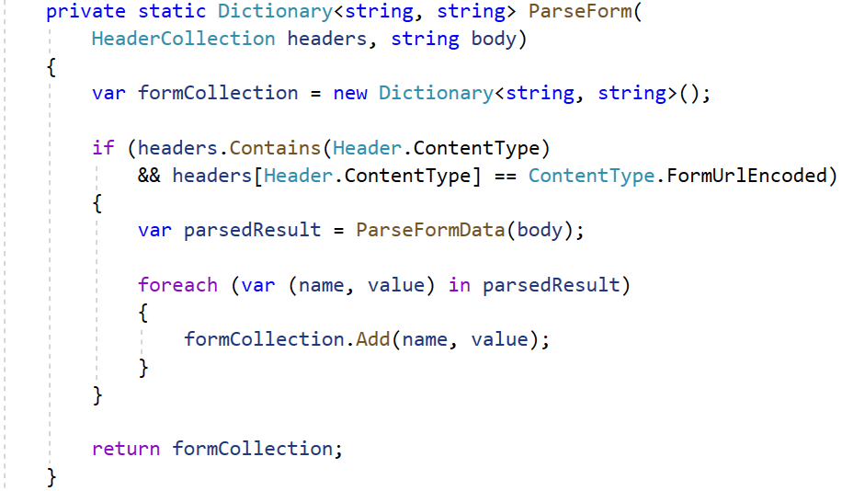

Step 3: Modify Response Result
Now we have the functionality to obtain the form data from the HTTP request. Now we should return a response, visualizing the data in the way we want.
First, go to the Startup class and modify the "POST" request, which returns a response when the HTML form is submitted:
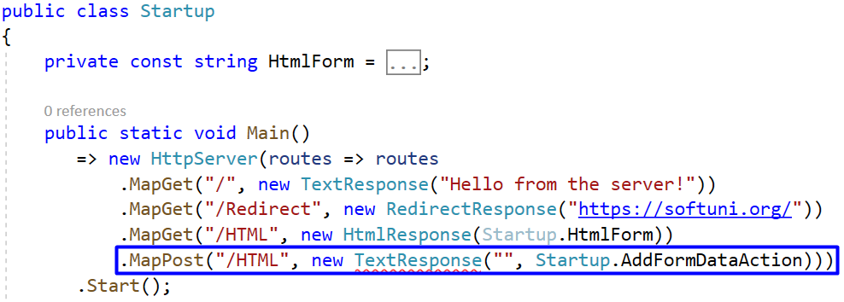
As you can see, we have a second parameter in the TextResponse class constructor: this is the name of a pre-render action, which will use the request and modify the response before it is returned to the browser. Let's see how we will modify the response to be as we want it.
First, we will allow the action to be executed in the response. Go to the Response class and add the PreRenderAction property, which accepts a Request and Response and does not return a result:
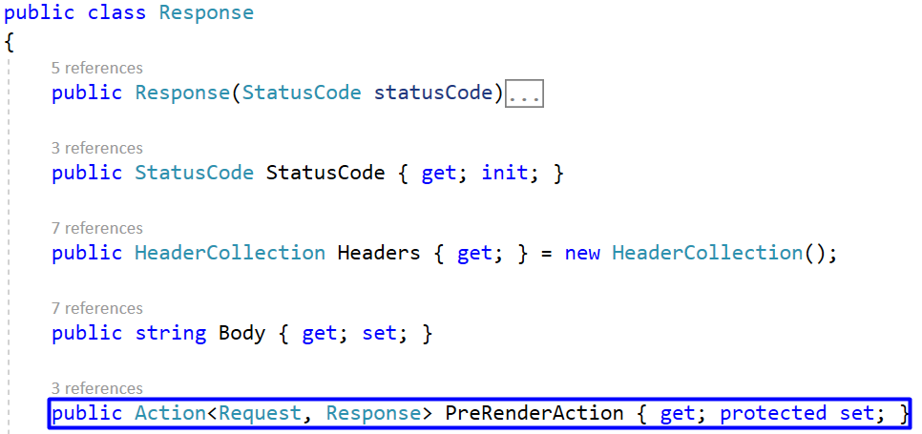
Then, modify the ContentResponse child class to accept the action through the constructor as an optional parameter and set it like this:
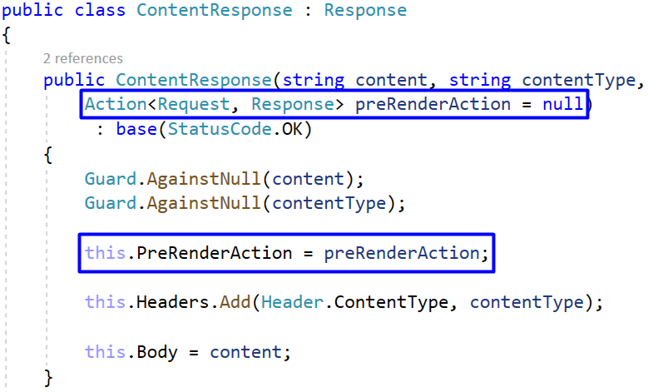

At the end, go to the TextResponse class and change its constructor, as well:
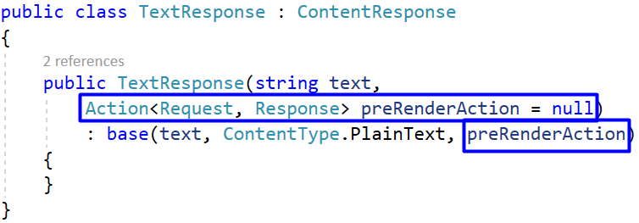
We have the pre-response action property in the Response. It should be executed after the request is parsed from the browser, as its form data is used, and before the response is returned to the browser. That's why we should add the following lines to the while-loop of the Start() method in the HttpServer class:
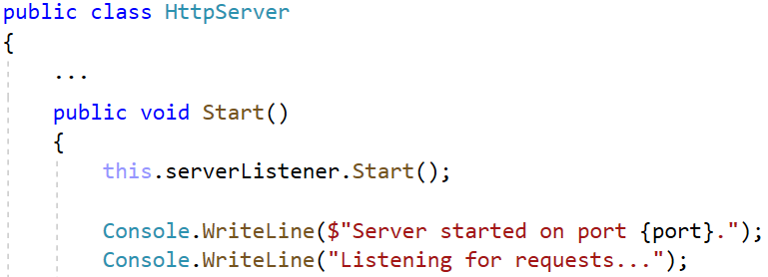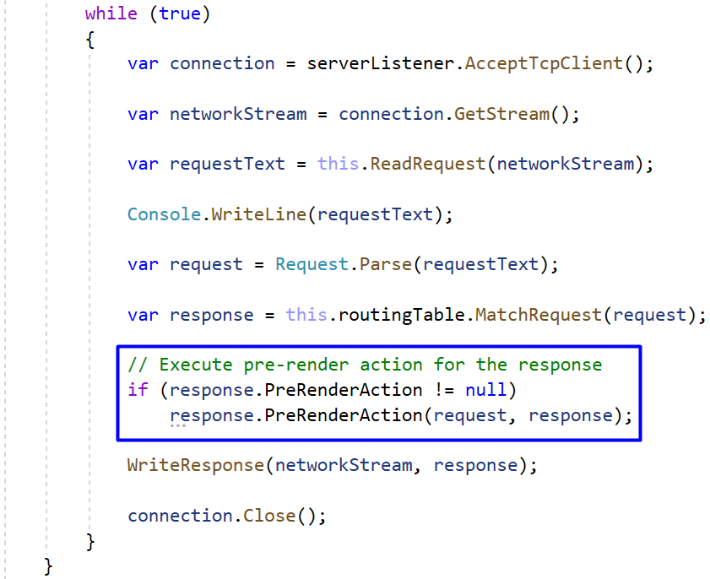


Step 4: Create a Pre-Render Action and Try It Out
Now we can add an action to be executed before the response is returned. Go back to the Startup class of the "BasicWebServer.Demo" project and create the AddFormDataAction(Request request, Response response) method, in which we will add the form data to the response body:
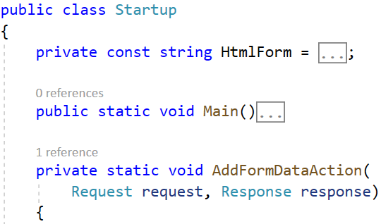
In this method, you should only clear the response body content, so that only current data is displayed, and add each key-value pair of form data to it like this:
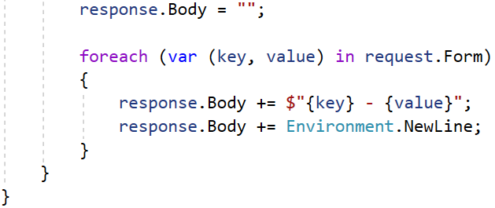
Now try the form parsing. Connect to our server in the browser, go to "/HTML", fill in the form and see if the returned form data is correct. Examine the requests and responses in the Network tab in the DevTools:
